WEST PARLEY GARDENING CLUB

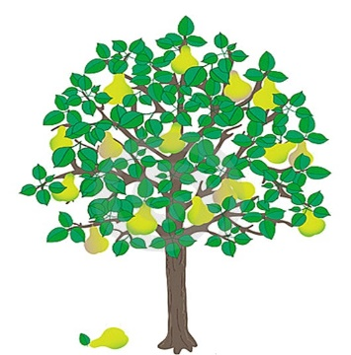

WEST PARLEY GARDENING CLUB MEETS ON THE LAST TUESDAY OF THE MONTH AT THE MS CENTRE DORSET, CHURCH LANE, WEST PARLEY, BH22 8TS.
WE HAVE A FULL PROGRAMME OF SPEAKERS THROUGHOUT THE YEAR, COVERING SUCH TOPICS AS ALL THINGS HORTICULTURAL, WILDLIFE AND LOCAL HISTORY.
MEMBERSHIP COSTS £15 PER YEAR OR £3 PER MEETING AS A VISITOR, AND ALL ARE VERY WELCOME.
WE HAVE A RAFFLE, A FLOWER COMPETITION, A SALES TABLE, AND LAST BUT NOT LEAST THE OPPORTUNITY TO ENJOY TEA, COFFEE AND CAKE!
THE CLUB ORGANISES AN ANNUAL COACH TRIP TO RHS WISLEY, SOME VISITS TO LOCAL GARDENS, AND A SUMMER SHOW THAT GIVES MEMBERS A CHANCE TO EXHIBIT FLOWERS, VEGETABLES AND HOME-MADE PRODUCE.

Please contact Rod Darch 01202 896711, rod@rdconsulting.co
westparleygc.co.uk

