West Parley Heritage Walk
(approx. 4 1/2 miles)

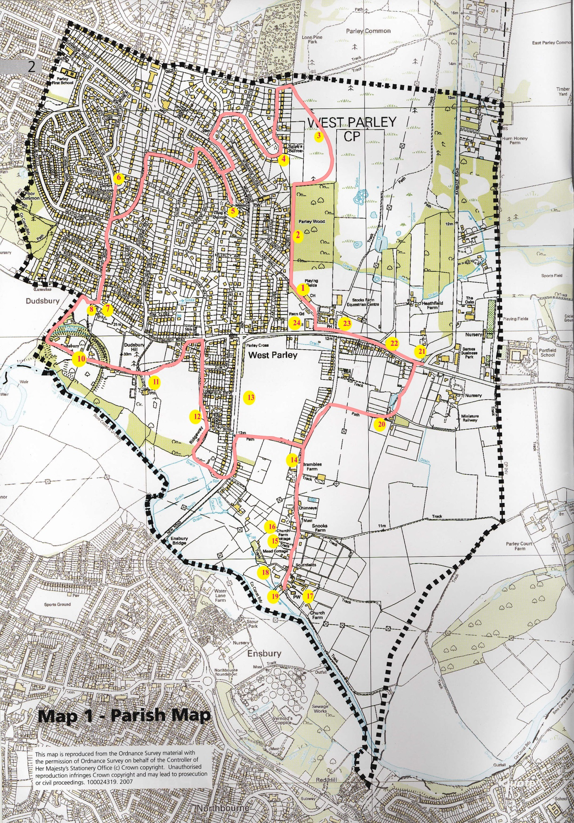

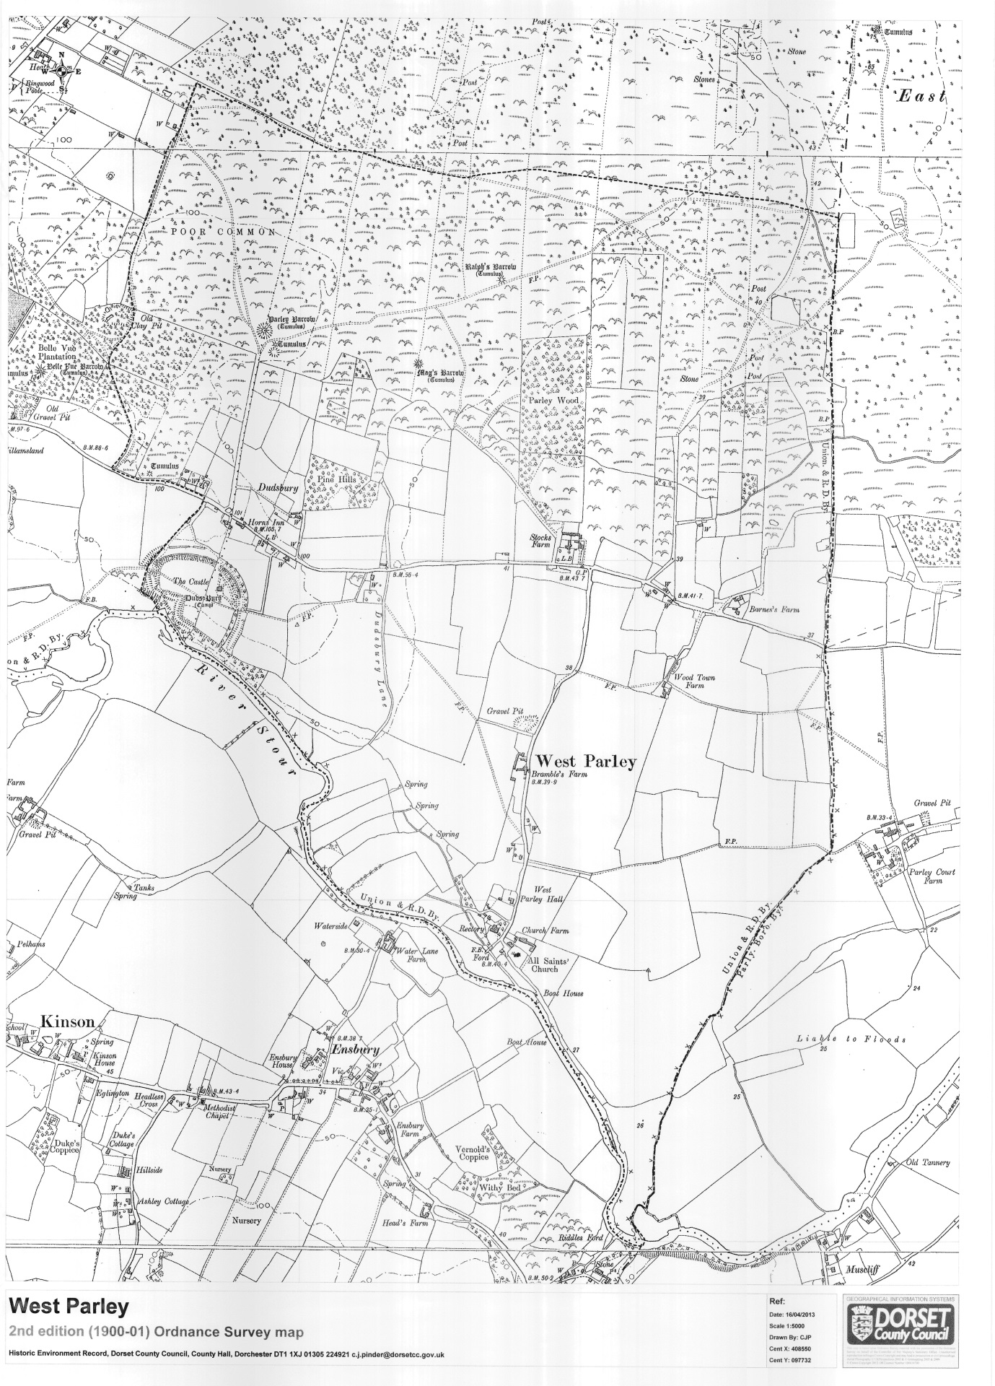

West Parley 1900-01 Ordinance Survey map
Start point for the Heritage Walk: At the west end of the parish car park on the north side of Christchurch Road. The numbers below are on the map of the route round the village.
1. Track to Woodland Walk - This track was known to have had a number of uses, suggested to have been an ox drove track, a path from the clay pits on Poor Common where bricks were made and as a turf cutters track joining West Parley to Dudsbury and West Parley Commons.
2. Parley Wood - This is 17 acres of ancient natural woodland, shown first on 17th century maps as one of the few areas of woodland in West Parley, as most of the village was small scale agriculture or heathland. The Wood was well used by local residents. Hazel in the wood was coppiced for hurdles and fencing and birch and oak trees were felled regularly until 1945.
There are a number of oak trees on the boundary that are much older than oaks within the Wood. Some of these are around 160 years old.
The Wood can get flooded as it is low lying and drainage to the west across to the Moors River is poor. Until 7 years ago the whole of the Wood was covered with invasive holly but this is being removed each Winter to restore the woodland and to encourage a broader range of flora and fauna. Paths have been improved by a team of West Parley Volunteers to improve access to the Wood to encourage residents and visitors to enjoy this unique area.

3. Parley Common - This large area of restored heathland is part of a once extensive area of heath across south and east Dorset. Cattle used to be grazed here and heather turves were dug for fuel and bracken cut for animal bedding as part of local subsistence farming. The open common was split into individual ownership in 1633 and medieval ditch and bank boundaries were cut that can still be found around and within the Common.
A large number of trees have been cut in the last 16 years to restore the heathland habitat for protected species, such as lizards, snakes and newts. Summer cattle grazing has been reintroduced here as part of the heath management scheme.
Old maps show tracks across the north part of the Common that were part of the old road from Poole to London via Longham and Palmers Ford (close to the current A31) through Ringwood before the toll road, that became the A31, was built.
4. Ralphs Barrow - On the bend in Lone Pine Drive is a Bronze Age (2350BC – 701BC) bowl barrow, one of 3 in the village. The barrow is a burial site for a tribal chief and is accompanied by burial goods to help with the journey to the afterlife. The bowl is 7ft high with a 90ft diameter. These barrows used to offer extensive views from higher ground across the Stour valley and beyond to the Isle of Wight. The importance and significance of these barrows is being increasingly understood as are the rituals associated with burials.
5. Mags Barrow - This is in the front garden of number 52 Mags Barrow and can be seen from the front gate. The Bronze Age barrow is another bowl barrow, some 84ft in diameter and 6ft high. It was circled by a ditch but now infilled. It was excavated in 1924 and a number of grave goods were found. This barrow is on one of the highest parts of West Parley.
6. Parley Barrow - Take a short detour to the right when coming out of the end of Dudsbury Road to find another Bronze Age barrow, on the corner of Druids Close. This one is 104ft across and over 9ft high. Another, smaller, bowl barrow was close to Parley Barrow, to the SE, but it has been destroyed by housing development.
The large oak trees on the left hand side of Dudsbury Road follow the ancient field boundary here. Historic boundary trees are found in many places across West Parley as housing development infilled existing fields and pastures but the boundaries remained. These fields can be traced back to the medieval period as many of them have distinctive kinks in them that are a feature of medieval ploughing. These are mainly found in the fields closer to the Stour.
It is very likely that some field boundaries in the village are prehistoric.
7. Dudsbury settlement - At the end of Dudsbury Road you are entering a part of the current village of West Parley that was the separate hamlet of Dudsbury, mentioned in the Domesday Book. There were a number of cob walled farms and cottages on the main Christchurch Road that have been replaced with more modern buildings.
8. Horns Inn - This building was built in the 17th century and has been an inn since that time. Inns were often just rooms in private houses with beer brewed locally. Being on the main road between Wimborne and Christchurch it was well used by travellers and it is easy to visualise this location at the top of the hill being a welcome stopping point.
There are a number of large oak trees here. The tree in the car park and others close by are some 300 years old.
9. Dudsbury Barrow - There was a large barrow over the road on the corner of Linden Road and Christchurch Road where there are now 2 bungalows. It was excavated in 1935 and was found to be in 2 phases. The initial mound, about 35ft in diameter was composed mostly of turves that covered an oval grave of sand which once held a crouched inhumation. The mound was later enlarged and a substantial ditch was cut around it and a secondary cremation under an inverted collared or ridged food - vessel urn was placed in it. After excavation the barrow was removed.
Despite its removal there will be evidence of the barrow on this site as the infilled ditch will be of a different material than the surrounding natural ground.
Just out of sight on the road west to Longham and Wimborne stands a large former farmhouse called Hilliamsland which is now part of Dudsbury Golf Club. It was owned between 1791 to 1793 by the infamous local smuggler, Isaac Gulliver, who dominated the local smuggling trade for many years. There are large cellars under the building.
It is known that goods landed at Christchurch would have been moved through Hurn and West Parley at this point on their way west to Wimborne and on to Cranborne.
In the woods on the north side of Christchurch Road opposite Hilliamsland was one of almost 500 bases built after 1940 as part of a resistance movement created by Prime Minister Churchill to hinder any German advance in the event of invasion. This was manned by a secret Auxiliary unit formed of some of the best Home Guard members and other local men. These units were stood down in 1944 and the Bases fell into disuse. Thought at the time to have been an air raid shelter, it was only in the 1960s that details of the real use of these Bases were revealed.
Just north of the old Base on Poor Common is a large claypit that supplied bricks for the village until the early 20th Century.
10. Dudsbury Camp - As you enter the track off Christchurch Road, have a look firstly to the right and imagine a clear view across the Stour Valley to Bournemouth and Poole. This is roughly the extensive view from Dudsbury Barrow that prehistoric settlers would require when placing a barrow.
The oak tree on the right hand side is around 360 years old, one of the oldest standing trees in the village. The 2 on the main road are over 300 years old.
Further along the track on the left hand side you can see the 2 rings of the hill fort. This Iron Age (700BC-43AD) fort could have been built on existing defence works on the highest ground on the edge of the River Stour. Double rampart defences enclose a centre of about 8 acres. The openings on the south west and west sides are probably original. The steep side to the south is due to the River Stour eroding the cliff since originally built.
In its original form the fort would have been an impressive structure with the ramparts topped with wooden posts and the ditches considerably deeper than they are now.
The Camp is a Scheduled Monument of national importance. There was a limited excavation of the site in the 1920s to define the extent of the original banks and ditches and Iron Age pottery finds were made. Small items of Roman pottery have been found 300yds to the east.
The west side of the site is owned by the Girl Guides who have held camps here since 1931. In 2017 the Guides carried out a heritage project to raise awareness of the site and its use by the Guides. Much overgrown vegetation was cleared and Bournemouth University carried out a ground radar scan to try to find any historic items (without success). Signage was put up and many trees on the south part of the hill fort were removed to restore the tremendous views south towards Bournemouth that would have been a feature of the original hill fort.
The most significant part of the project was the construction by Guides, their families and West Parley Volunteers of a replica of an Iron Age roundhouse using local materials wherever possible. The roundhouse construction was entered into the Community Project section of the 2017 Dorset Best Kept Village competition and gained a second place as reward for all the hard work involved in its construction.
The east side is owned by Castle Rings, the large house to the north of the footpath.
11. The Dudsbury - This has been a popular public house for many years though it is closed temporary. It was built in 1928 as a gentleman’s residence on one of the highest parts of the village with superb views from the east side across to the Isle of Wight. Romano-British pottery (made in the New Forest) was found when the footings were dug for the building. The old oak tree on the approach road is some 325 years old, one of the oldest trees in the village.
When walking across the fields downhill note that much of this area to the left and right is planned for a large housing development that will transform this most enjoyable area of the village.
There has been some settlement here through the ages, especially as this is next to the Iron Age Hill fort. Its construction would have required a workforce of thousands, settled here over many years or decades. The land here is dry yet there are fresh water springs locally in Ridgeway at the bottom of the hill.
12. Ridgeway - Before turning into Ridgeway look round and up Christchurch Road. Up the hill on the left before the Horns Inn were a number of cob farm buildings being part of the now-demolished Dudsbury Farm. On the opposite corner were 2 cob cottages for shepherds.
Ridgeway is an ancient track leading to the River Stour. Once known as Dudsbury Lane, and is very likely to have been used by smugglers after crossing the Stour. Kinson, in north Bournemouth, was well known as a centre of the trade after goods were landed on the coast and came inland on a network of tracks across the heathland. The obvious crossing point of the Stour locally was over the bridge at Longham but this could be easily monitored by the customs men so another crossing point nearby was needed.
Just west of the Hill Fort the River Stour is shallower and it is thought that goods crossing there by boat, or horse and cart were brought along a track on the north bank and then north up the track via Ridgeway and across Parley Common to Ringwood.
As you walk down the track towards the river notice the 2 large trees that are probably at least 300 years old.
13. Field on New Road - The large field was once one of the many plant nurseries in the area that were run by Stewarts, a Scottish based firm that started as a business growing forestry trees as far back at 1742. To take advantage of the milder climate in the south, a descendent of the founder opened the first of its Dorset nurseries in Ferndown in 1859.
The two arms of the business thrived and traded widely throughout Britain, the Continent and the USA. In the early 20th century the firm was the largest producer of nursery stock in the country overcoming occasional difficult trading conditions.
The large Parley site was an important part of the business. On a 1928 map the site is shown as being divided into 7 large areas with a small building next to New Road. There were no houses close to the site, the nearest at the time being in Church Lane and Stocks Farm showing how recent almost all houses here have been built.
In WW2 the land was worked for essential food production by many German and Italian prisoners of war due to the labour shortage. The Germans were brought in by lorry from a camp at West Moors and after 1943, when Italy surrendered, Italian POWs were housed in a number of huts on land off Chine Walk in West Parley that had housed construction workers when the Airport was built from 1939.
The nursery closed in 1955. Other local centres around here were at Longham (now the site of Haskins), Uddens and West Moors. There were 2 nurseries in Bournemouth and others in Somerset and Sussex.
Despite mechanisation, the nursery would have been a good employer and make an essential contribution to the local economy.
After such intensive cultivation the land is now less used, being grass meadow cut each Autumn. A number of deer are often seen in the field enjoying the safety of the large open area.
In the mid-1970s a superstore was planned for the site but permission was refused. The land has now been allocated for housing development as part of local housing strategy and planning permission is being sought for 386 houses, retail and office units and a foodstore along with a link road despite fierce local opposition.
14. Brambles House - This is the former farmhouse of Brambles Farm and is of red brick patterned with blue header bricks. It was built in the early C18 but Tudor origins have been found in the building. Note the cob walls on the front to both right and left of the building and the letters JMB on the south end wall. These are believed to stand for James and Margaret Brambles, once owners of the building. The building is Grade 2 listed.
There are medieval field boundaries in local fields. This is one of many ancient farms in this area on drier land away from the Stour flood plain.
All the houses in this area were part of the original hamlet of West Parley.
15. Mead Cottage - This charming house was once 2 farm cottages, built around the late 1700s / early 1800s. There is a Victorian extension on the side. Old pottery, oyster shells and glass debris have been found in the paddock at the side of the house. It was common around the parish for pits to be dug to remove clay and gravel for local use and holes to be left to infill with water for animals to use or backfilled with rubbish, as is the case here.
On old maps the cottage is called West Parley Hall and may have been known as West Parley Manor but this is confusing as the design both in and out does not indicate any open space for public meetings and the construction is basic. Some residents say a Hall was used as a cinema here, but this may have been the rear of the old Rectory close by that may have had a small room to the rear.
16. Church Farm - This is one of the main buildings within the Conservation area which is defined by the mellow orange / red brick used as walling for the Old Rectory, Appletree Cottage, All Saints Church and Church Farm. Little has changed here for hundreds of years. The farmhouse and barn were built in late 18th century and comprise of a 5 bay 2 storey building plus an attic and cellar.
17. All Saints Church. - This is the best known historical building in the village and though the nave has mid 12th century origins, it is thought to have replaced a Saxon church, which may well have replaced an even earlier church. There is a yew tree close to the church entrance, always a sign of a religious site, but it is not old, looking like side growth from a former tree.
The porch is 15/16th century, the steeple was built about 1792.The door hinges are 12th century. Much of the church was rebuilt in 1896 but many of the original window frames reused. The building is listed.
Look at the sundial on the approach path to Church. It was part of the post from a gibbet that was used to display the bodies of 2 murderers from East Parley in 1803. The gibbet, on East Parley Common, was the last gibbet to be used in the south of England.
Outside, on the east wall, set in a barred recess, is an urn said to contain the heart of the Lady of Lydlinch. Once the Lady of the Manor of West Parley in the 1300s, she was made by her husband to live at Lydlinch, near Sherborne. She said that as her heart was in West Parley she wished a part of her to go there on her death.
In the churchyard close to the entrance gate is a cross in memory of 2 sisters drowned in the Stour in 1908.
The building of St Marks Church and adjoining Rectory in New Road in 1957 moved the centre of worship from All Saints.
The lane to the right of the church continues along the edge of the River Stour to a former ferry crossing at Riddles Ford that took locals into Bournemouth via Redhill. This was a prehistoric river crossing on a trackway from Ringwood direct to the coast close to Parkstone.
In the 17th and 18th Century this crossing was another route used by local smugglers and goods went directly north or north- west along the track by the church then via Church Lane to Wimborne.
18. Old Rectory - This is of classic Regency design. Part of it was used as a church hall and meeting room until the building was sold by the Church in 1947. It is a Grade 2 listed building.
19. Crossing point / boat house - Have a look at the lane by the side of Appletree Cottage leading to the River Stour. Old maps show a boat house and dock at the end of the lane. With no bridge to Bournemouth over the Stour from West Parley till 1910, residents could only cross the Stour at a couple of places. The crossing here was by boat and possibly by a chair on a rope. When the river was low, horses and carts could cross with care at other places.
20. Wood Town Farm - After walking back up Church Lane, turn right on to the footpath to Wood Town Farm. A local map of 1860 says ‘Traces of Folk Moot site’ just to the west of the farmhouse. A folk moot is a general meeting place for parish residents in medieval times to discuss and resolve local issues and disputes.
The farmhouse has cob walls on footings of brick and heathstone. The original building is early 17th century. Early in the 19th century the main room was divided and a further room was added to the south end. Just to the north of the farm Iron Age finds were made in 1929 when clearing out a duck pond and 4th century Romano-British occupational debris has been found to south east.
21. Barnes Farm - On the corner of Barrack Road was a smallholding called Barnes Farm. This is now Wyevale nursery and the coffee shop in the nursery was an old barn. In the coffee shop are a number of maps and old photos of West Parley that are worth a look at.
Behind the nursery, in Barrack Road and the adjoining paddock, there are some of the old trees, being around 250 years old. Barrack Road is named after 2 parish almshouses that were on the second bend in the road, in what is now the Barnes Industrial Estate.
The almshouses were called ‘The Barracks’ to reflect the poor conditions in the semi detached houses. They were built in 1830 with borrowed money to house the village poor but became an increasing drain on the parish funds and were sold in the late 1850’s.
Barrack Road itself follows a narrow strip of land almost 1 ½ miles long that was a parcel of land allocated to a John Bolton in the 1633 division of the heath. It marks the boundary between West and East Parley Commons. Half way up the road on East Parley Common a claypit and kiln supplied bricks for local use. Whilst this brickyard, and the one further east on Poor Common, were the brick manufacturers, clay was dug from a number of claypits around the village and made into bricks at the 2 kilns. The smaller claypits filled with water when the clay ran out and were used as ponds for farm animals.
22. Houses in Christchurch Road. - Have a look at numbers 366, 358 and 356 that are from the mid 18th century. 356 has old wall ties to keep it straight, one of the few houses in the village needing this support. Part of the wall is cob. Old maps of this area south of Christchurch Road show a number of other old houses but they are no longer here. They were probably cob farm cottages.
23. Curlew Inn - The building can be traced to 1841as the farmhouse for Stocks Farm, a smallholding. It was built by a Wimborne banker and partner in a fishing company with 40 boats plying between Poole and Newfoundland. The front was given a Grade II listing in 1955. The village stocks were reputed to have been located outside the farmhouse. The junction here with Church Lane is the original West Parley crossroads, until New Road and Ensbury Bridge were built. In the field opposite the Curlew was one of the largest ponds in the village as shown on an 1860 map but it has long been infilled.
24. West Parley Memorial Hall - The current Hall was opened in 1964 to replace a former Hall to the north that was opened in 1948. It contains the village WW1 and WW2 memorials. The Hall can accommodate up to 250 people at meetings and 150 seated at tables for social occasions and activities.
25. Parley Sports Club - The Sports Club dates from the late 1940s when the land was cleared for playing fields and a small pavilion and changing rooms erected. The current clubhouse was erected in 1961 and opened by John Arlott.
Return to the Car Park. Hopefully you enjoyed this walk!

