The Boundaries of West Parley
The modern civil parish of West Parley is a recent creation, dating from 1956. The parish has changed considerably over the last 150 years, in part because of changes in local government introduced during the C19 and partly as a response to the very considerable growth in population in the area particularly from the beginning of the C20.
Samuel Lewis in his ‘Topographical Dictionary of England’ published in 1831 describes West Parley as follows:
PARLEY,WEST, a parish in that part of the hundred of CRANBORNE which is in the Wimborne division of the county of DORSET, 6½ miles (E.S.E.) from Wimborne-Minster, containing 235 inhabitants. The living is a rectory, in the archdeaconry of Dorset, and diocese of Bristol, rated in the king’s books at £6. 17.6., and in the patronage of Thomas Deverell, Esq., and others. There is a place of worship for independents.
This description starts by placing the parish in its administrative context. The main administrative divisions of the county, originating in the Anglo-Saxon Wessex state administration, were the Hundreds. Cranborne Hundred was one of the larger Dorset Hundreds, and covered substantial areas of the eastern part of the county. However, like many of the administrative units of the period, this was not a continuous area and included several different areas separated from each other. The Hundreds had a Lord and a Hundred court. One of the duties of this court was to appoint officers for the Hundred including a High Constable and a Coroner.
The description goes on to place West Parley ‘in the Wimborne division’ of the County of Dorset. This refers to the other main administrative areas in the county at this period. Much of the administrative work of the county was carried out not by the Hundred courts, but by the Justices of the Peace, meeting at Quarter Sessions. As the name implies, these sessions were held four times a year, and are often referred to by the religious festivals to which they are related, such as Epiphany and Michaelmas. The large number of hundreds meant that the local administration was based on groups of hundreds rather than on individual hundreds. This alternative grouping was based on the Petty Sessional Divisions of the Justices of the Peace. John Rickman, Clerk to the House of Commons, who organised the 1831 Census wrote in the Preface to that Census: ‘Hampshire and Dorset have been arranged (time out of mind) in Divisions which obviate the inconvenience of numerous small Hundreds ...’ The original Civil Divisions were simple groupings of Hundreds. Originally five, they were increased to 9 in 1740. However, the geographical spread of the Hundreds made this arrangement increasing impracticable, and the Division of Counties Act 1828 (9. Geo. IV, c. 43), an Act ‘for the better Regulation of Divisions in the several Counties of England and Wales’, gave the Justices of the Peace the power to establish Divisions which ‘in the opinion of the Justice of the Peace would form together a convenient and proper Division’. This led to a rearrangement of these 9 Divisions and in 1830 the new Divisional boundaries were adopted. West Parley formed part of the Wimborne Civil Division, although, as Lewis’ text makes clear, other parts of Cranborne Hundred were in other Petty Sessional Divisions.
A third type of administrative area was created shortly after Lewis’ entry was written. The Poor Law Amendment Act 1834 (4 & 5 Will. IV c. 76) required parishes to join together into groups to provide relief for the poor. Wimborne Poor Law Union formally came into existence on 28th September 1835, and consisted of 10 parishes including Hampreston, West Parley and Wimborne Minster. A second Poor Law Union based on Cranborne was also created in 1835, but the two Unions merged to form the Wimborne and Cranborne Union in October 1836. Canford Magna became part of the Poole Poor Law Union.
The Parish itself included West Parley and three hamlets: Dudsbury, Layfield and West Moors. Figure 1 shows the boundaries of this parish in orange. It consists of two roughly rectangular areas, joined at a corner, with West Moors as a detached part of the parish. The map also shows the County boundary between Dorset and Hampshire (in blue) running down the eastern boundary of the southerly part of the parish. The parish was surrounded to the south by Kinson, a chapelry in the parish of Canford Magna (also known as Great Canford in an ecclesiastical context), to the west by Hampreston, Wimborne and a detached part of Gussage All Saints, to the north by Cranborne and to the east by Cranborne, a short boundary with Ringwood (in Hampshire), a detached part of Cranborne and Christchurch (also in Hampshire). The boundaries of these surrounding parishes are not shown in detail, but the junctions with the boundaries of West Parley are shown.
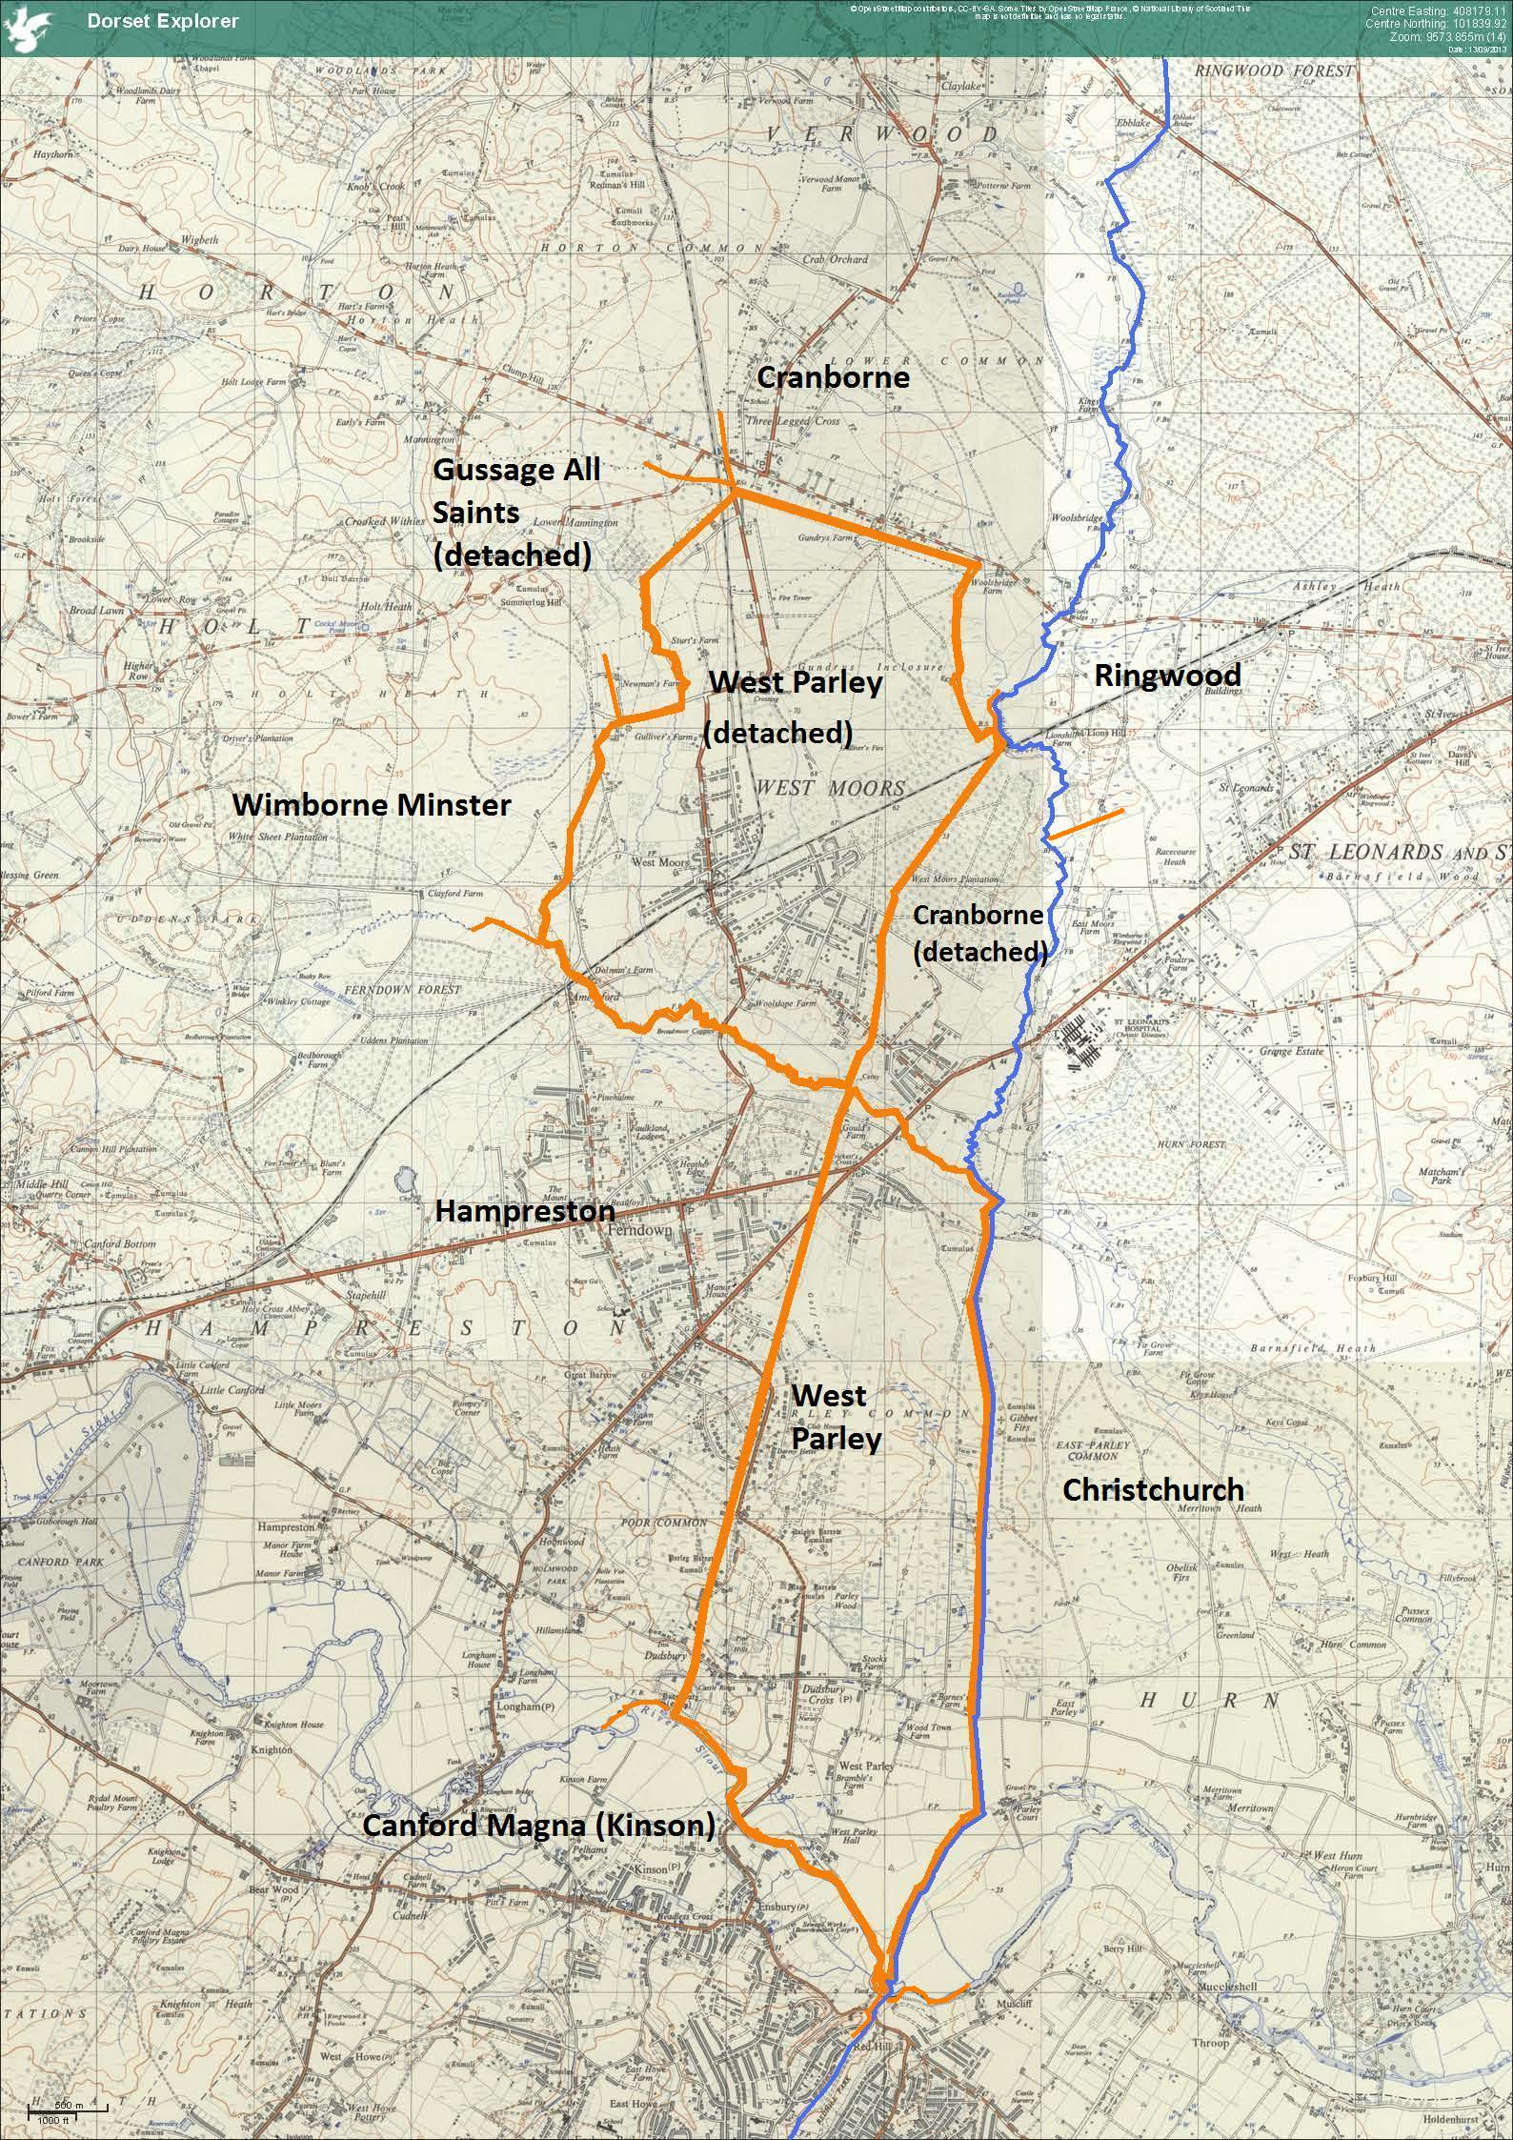
Figure 1. The boundaries of West Parley at the time of the Tithe map in 1840. ©JWH based on Dorset Explorer 1958 OS map, based on Ordnance Survey material with the permission of Ordnance Survey on behalf of the Controller of Her Majesty’s Stationary Office. © Crown Copyright 2013. © Dorset County Council.
The 1861 Census shows the area of the parish as 3407 acres, with a population of 286 in 1851 falling to 268 in 1861, living in a total of 61 inhabited buildings.
Whilst the parish is rather larger than the average for Dorset as a whole, this is not at all unusual for this part of the county.
The areas and 1851 populations of these parishes are shown in the 1861 Census as follows:
Parish | Area (Statute acres) | 1851 Population | 1851 Population / statute acre (x100)
West Parley | 3407 | 286 | 8.4
Hampreston | 4948 | 1387 | 28.0
Ringwood | 8050 | 3928 | 48.8
Wimborne | 11966 | 4759 | 39.8
Cranborne | 13730 | 2737 | 19.9
Canford Magna | 17739 | 4065 | 22.9
Christchurch | 24985 | 6256 | 25.0
The table above shows that although the parish is smaller than its neighbours, the population density is much lower than in the surrounding parishes.
The need for a more efficient administration of the Poor Law led to important changes in the administrative geography, in particular resulting in the amalgamation of areas into more coherent units. At the same time, the sheer size of some of these units, particularly ecclesiastical parishes, with long distances between churches, led to the creation of smaller and more manageable parishes.
Canford Magna was now too large a parish to administer as a single unit, and in 1834, the separate ecclesiastical parish of Parkstone St. Peter was created. In 1865 the chapelry of Kinson was also made a separate ecclesiastical parish. Even before it became a separate ecclesiastical parish, Kinson had levied its own Poor Law Rate and hence became a separate civil parish in 1866 as a result of a change in Poor Law legislation. The Poor Law Amendment Act 1866 (29 & 30 Victoria, c. 113) changed the definition of ‘parish’ so that all areas that levied a separate rate (including extra-parochial places, townships and chapelries) were defined as separate civil parishes. The new parish of Kinson was 4390 statute acres.
The Ordnance Survey had been given powers by the Ordnance Survey Act 1841 (4 & 5 Vict. c 30) to carry out a survey of Great Britain, Berwick-upon-Tweed, and the Isle of Man. Part of this work was carried out by the Ordnance Survey Boundaries Branch, whose task it was to establish administrative boundaries. In 1866, the boundaries of Holdenhurst, Christchurch and Ringwood including the county boundary to Great Canford and West Parley were surveyed. The survey identified several small detached parts of Christchurch in Holdenhurst, and other detached parts of Holdenhurst in Christchurch. The boundaries were then shown on large scale Sketch Maps. These maps were later annotated to show the subsequent changes to parish boundaries.
Detached parts of parishes were the cause of a number of problems in administration of the Poor Laws, and active measures were taken in the 1870s to rationalise the boundaries in order to resolve these problems. The Divided Parishes and Poor Law Amendment Act 1876 (39 & 40 Vict. c. 61) and the Poor Law Act 1879 (42 & 43 Vict. c. 54) gave the Local Government Board powers to place detached parts of parishes in adjacent or surrounding parishes, or, where the population was large enough, create a new parish. The second Act also provided powers so that areas inconvenient for local administration, such as those astride a river or a higher-order unit boundary could be re-grouped. These powers were used by the Local Government Board to draw up an Order at the end of 1884 reorganising the boundaries of several parishes in the Wimborne and Cranborne Poor Law Union, including the detached part of Cranborne which included St Leonard’s Farm to West Parley. The Order also transferred the detached part of Gussage All Saints on the western boundary of the detached part of West Parley to Wimborne Minster. For some reason, this Order was considered unsatisfactory (it included no reference to the Highway Districts concerned) and was rescinded shortly afterwards by a subsequent Order. A second attempt later the same year successfully transferred the detached part of Cranborne parish which divided the two areas of West Parley parish to West Parley with effect from the 24th March 1886. The result was a parish with coherent boundaries and an area of 3954 statute acres. Figure 2 shows the boundaries of this parish after this transfer in orange. The map also shows the County boundary between Dorset and Hampshire (in blue) running down almost the whole length of the eastern boundary of the parish. The new civilparish was bordered by the parishes of Kinson to the south, Hampreston and Wimborne Minster to the west, Cranborne to the north and north-east, and Ringwood and Christchurch in Hampshire to the east.
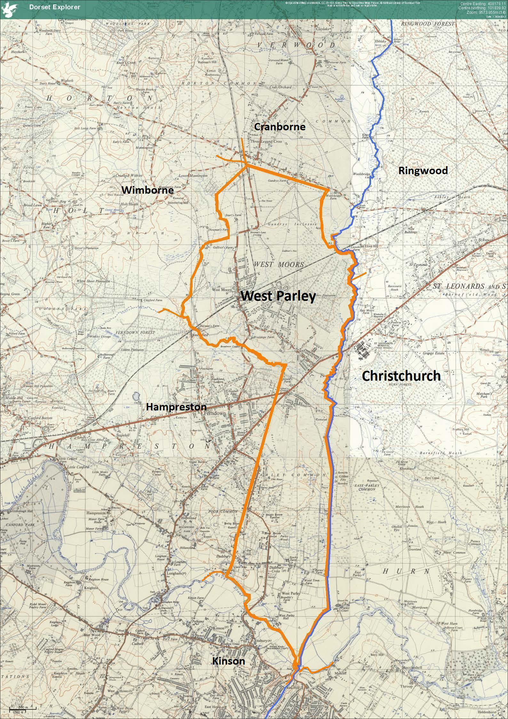
Figure 2. The boundaries of West Parley after the transfer of the detached part of Cranborne to West Parley on 25 March 1886. ©JWH based on Dorset Explorer 1958 OS map, based on Ordnance Survey material with the permission of Ordnance Survey on behalf of the Controller of Her Majesty’s Stationary Office. © Crown Copyright 2013. © Dorset County Council. 2013.
Less than a year after the creation of this larger civil parish, in January 1887 the ecclesiastical boundaries were redrawn, and a new parish of Verwood and West Moors created from the southern part of the parish of Cranborne and the northern part of the parish of West Parley. In the reasons given for the change, the Bishop of Salisbury notes that according to the 1881 Census, Cranborne Parish has a population of 2317, of which 854 live in the Verwood and Three Legged Cross area. The population of West Parley in the same Census was 336 with 189 living in the West Moors area. The Bishop also notes the distance between the hamlets and the main parish churches in Cranborne and West Parley (4½ and 7 miles respectively). According to the Bishop, the boundaries of these areas ‘are well known and defined’. By creating the new parish, the southern detached part of Cranborne with St Leonards Farm was merged with northern detached part of West Parley as had already occurred with the civil parish. The area remaining as West Parley ecclesiastical parish after this change corresponds to the southern part of the original parish shown in Figure 1, with the northern boundary following the same stream that formed the boundary to the detached part of Cranborne. The boundaries of this ecclesiastical parish remain unchanged.
At much the same time as these boundary changes were coming into effect, the Ordnance Survey Boundaries Branch carried out a new boundary survey in 1886, this time including the boundaries of West Parley with the surrounding Dorset parishes. These results were shown on a large scale Sketch Map. In order to ensure that the boundaries shown on these Sketch Maps were correct, the information was presented for inspection at Public Meetings held in Dorchester, Wareham, Poole and Wimborne from the 24th to 27th November 1885. No comments were received on the boundaries for West Parley.
The survey showed additional anomalies in parish boundaries which led to further changes. These changes affected many of West Parley’s neighbouring parishes, but did not affect the boundaries of West Parley itself.
In 1888, there were adjustments to the boundary between Kinson and Hampreston near Longham Bridge, mainly reflecting changes in the course of the River Stour. The changes came into effect on 24th March 1888. To the east in Hampshire, the northern part of Christchurch was transferred to Ringwood with effect from 29th March 1892.
The Local Government Act 1888 (51 & 52. Vict. c. 41) created the new ‘administrative’ county of Dorset. This resulted in a fundamental reorganisation in local government administration with the powers previously exercised by the Justices in Quarter Sessions and the Hundred courts transferred to the newly formed County Council. Further changes were introduced by the Local Government Act 1894 (56 & 57 Vict. c. 73) which established district councils as well as parish councils. The Poor Law Unions had been used as the basis for other administrative units including Registration Districts and Sanitary Districts. In areas with larger towns, Sanitary Districts were divided into separate Urban and Rural Districts, reflecting the differing needs of the two different types of area for the provision of sewage treatment, fresh water supplies etc. The area of the Wimborne and Cranborne Poor Law Union was made up of an Urban Sanitary District comprising the town of Wimborne, and a Rural Sanitary District comprising the remainder of the area. The 1894 Act replaced these Sanitary Districts by District Councils. As part of the Rural Sanitary District, West Parley thus became part of the Wimborne and Cranborne Rural District.
As Wimborne Minster civil parish was now part of both an Urban and a Rural District Council area, the parts of the parish in the area of the Rural District Council were separated off from the main parish and a new civil parish of Holt was created. This new parish became the new neighbour to the West Moors part of West Parley with effect from 30th September, 1894. To the north of the same part of West Parley, the growth in population in Verwood that had led to the creation of a separate ecclesiastical parish in 1887 led to similar changes in the civil parish boundaries. On 31st December 1894, the new civil parish of Verwood was created from the southern part of the Parish of Cranborne. On the Hampshire side of the county boundary, further reductions in the parish of Christchurch were made when the parish of Hurn was created on the same date, again as a result of changes needed to accommodate the new structure of District Councils. Two decades later, the boundary between Christchurch and Hurn was again changed, but this time with an area of 406 acres of Hurn returned to Christchurch with effect from 1st April 1912.
These changes to the detached parts of civil parishes had no effect on the boundaries of the corresponding ecclesiastical parishes. The detached part of Gussage St Michael, bordering the western boundary of the ecclesiastical parish of Verwood and West Moors was still isolated from its parent ecclesiastical parish. However, in 1922, by including this area with West Moors, a new independent ecclesiastical parish of West Moors separate from the ecclesiastical parish of Verwood was created. The detached part of Gussage St Michael was later transferred to the parish of Horton and Chalbury, leaving the ecclesiastical parish of West Moors covering the northern part of the civil parish of West Parley.
A major change took place with effect from 1st April 1931 when the parish of Kinson, immediately to the south of West Parley, was abolished to become part of Bournemouth. Following its creation as a separate civil parish in 1866, Kinson had lost an additional area in 1894 when the new civil parish of Branksome was created from the southern part of the parish. When the remaining 2769 acres was transferred to Bournemouth, they automatically changed county. As a result, the southern as well as the eastern boundary of West Parley became the county boundary.
Further changes on the Hampshire side of the West Parley boundary took place the following year, coming into effect on 1st April 1932 when a new civil parish, St. Leonards and St. Ives was created from parts of Hurn (1494 acres) and Ringwood (4660 acres). At the same time, an additional area of Hurn (943 acres) was transferred back to Christchurch.
In spite of the changes introduced in 1888 with the introduction of County Councils, some Hundreds retained their right to appoint Coroners until the 1926 Coroners (Amendment) Act (16 & 17 Geo. V, c. 59). The Act included a section ending the rights of individuals to appoint a Franchise Coroner at the next vacancy in the office, and transferred this right to the County Council. Cranborne Hundred had its own Franchise Coroner, and when the post fell vacant in 1937 was the last of the Franchise Coroner’s posts in Dorset. West Parley became part of the Eastern Coroner’s Division.
Minor changes to the parish and county boundary between West Parley and the new civil parish of St Leonards and St Ives took place with effect from the 15th August 1947. Small areas were exchanged between the two parishes as a result of diversions made to the course of the Moors River.
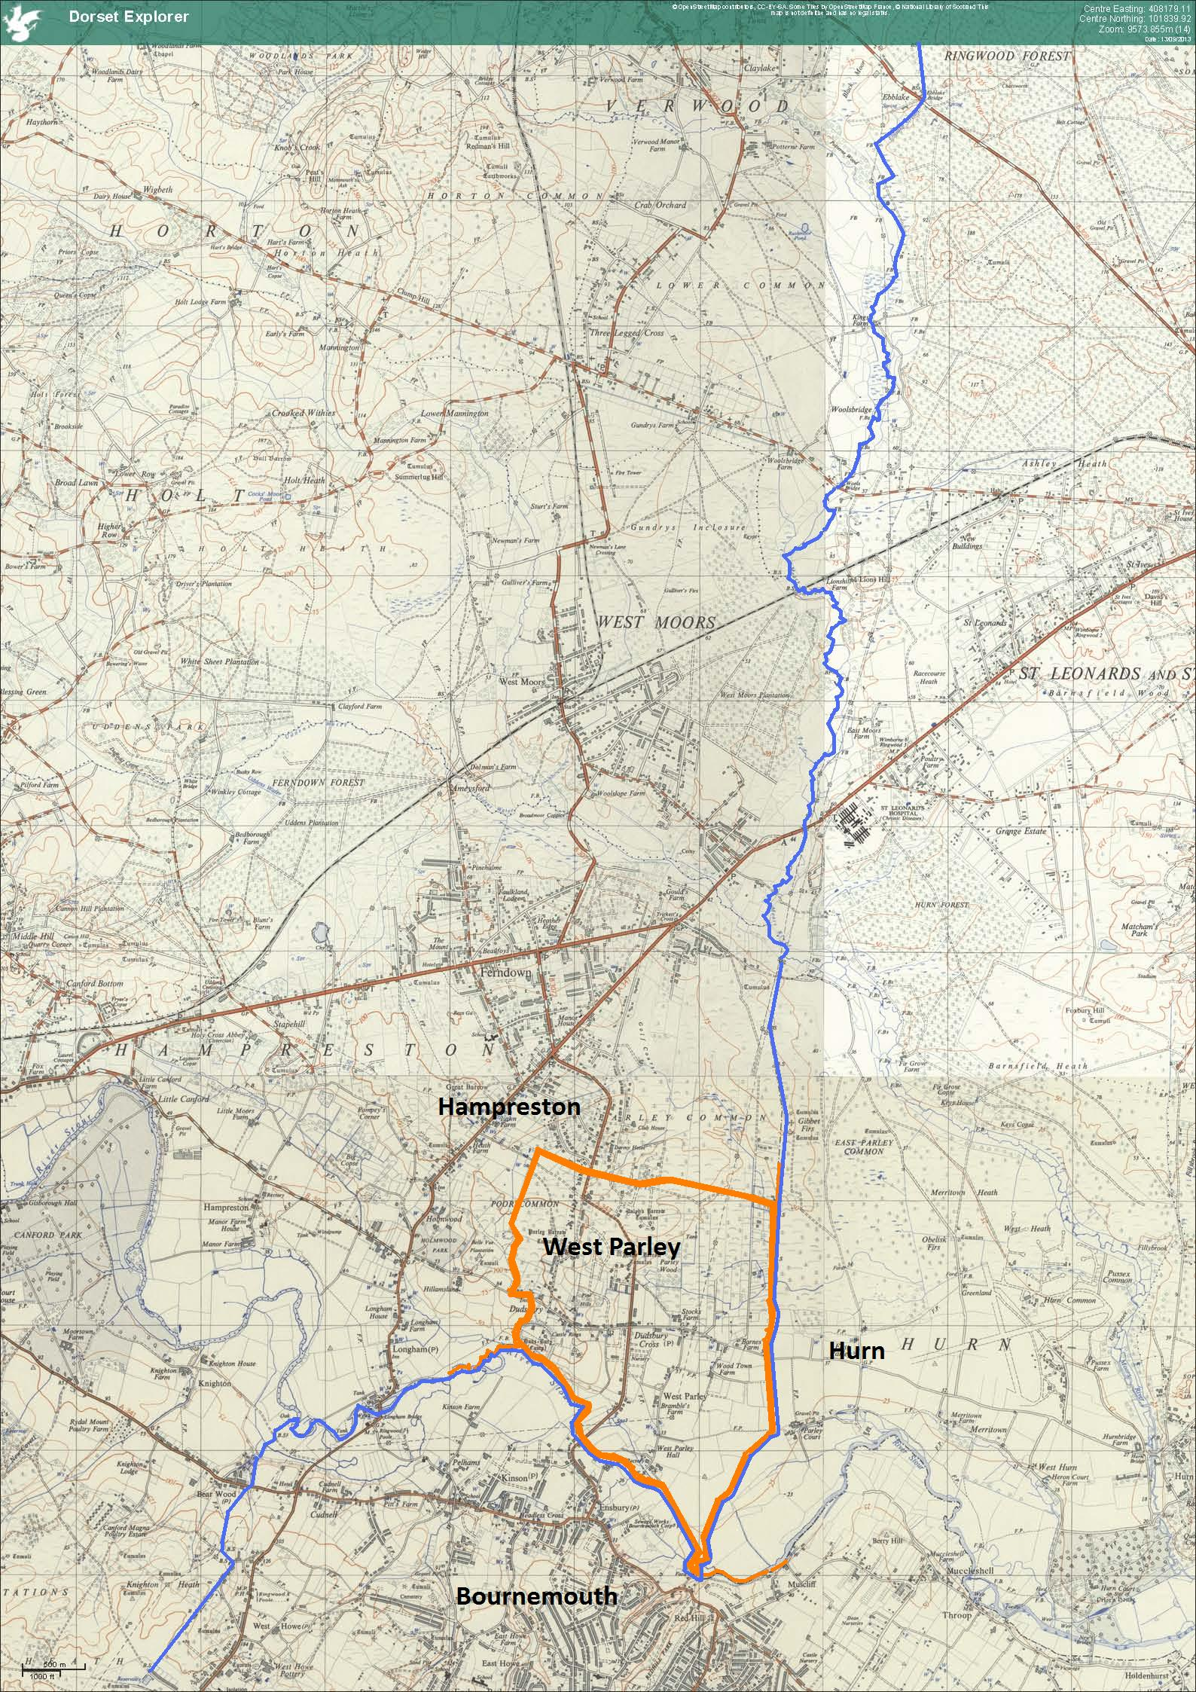
Figure 3. The boundaries of West Parley after the changes on 1st April 1965. ©JWH based on Dorset Explorer 1958 OS map, based on Ordnance Survey material with the permission of Ordnance Survey on behalf of the Controller of Her Majesty’s Stationary Office. © Crown Copyright 2013. © Dorset County Council. 2013.
The modern civil parish of West Parley was created in 1956, when considerable changes to the parish boundaries occurred. The two main changes were the creation of a new civil parish of West Moors and a transfer of much of the remaining area of West Parley to Hampreston to accommodate the expansion of Ferndown to the east.
The new civil parish of West Moors was very similar to the ecclesiastical parish created in 1922, but with two minor differences. A small strip along the northern boundary was transferred to Verwood (178 acres), and a small area of Holt parish in the east transferred to the new parish. The area transferred from Holt (64 acres) came from the area that was originally a detached part of Gussage All Saints, but whilst the whole of this detached part had been transferred to the ecclesiastical parish, only a small area was transferred to the civil parish.
The main loss to west Parley was the area ceded to create the new parish of West Moors (2047 acres). The loss of a large area of the middle of the parish (735 acres) to allow the expansion of Ferndown, was compensated to a much smaller extent by the transfer of land including an area of Dudsbury and part of Poor Common from Hampreston to West Parley (127 acres).
St Leonards and St Ives, now no longer a neighbour to West Parley, became a separate ecclesiastical parish in 1970.
The next major change occurred with the coming into force of the Local Government Act 1972 (20 & 21 Eliz. II, c. 70). A large area to the south and east of West Parley including the parishes of St Leonards and St Ives, Hurn, Bournemouth and Christchurch were transferred from Hampshire to Dorset. Whilst not affecting West Parley directly, the change meant that the parish was no longer on the boundaries of the county. The Local Government Act also led to the abolition of the Urban and Rural District Councils created as a result of the Local Government 1894. A new District Council, the Wimborne District Council was formed on 1st April 1974 by the merger of Wimborne Minster Urban District Council and Wimborne and Cranborne Urban District Council. The Council changed its name in 1988 to East Dorset District Council.
The predominance of Ferndown in the neighbouring civil parish of Hampreston was confirmed when the parish changed its name from ‘Hampreston’ to ‘Ferndown Town’ in 1986.
In 1997, Bournemouth and Poole were created as unitary authorities, and, as such, no longer formed part of the County of Dorset. The Dorset (Boroughs of Poole and Bournemouth) (Structural Change) Order 1995 removed the two Boroughs from the county of Dorset and created two new counties of Poole and Bournemouth. As a result, West Parley once more became a ‘boundary’ parish as the southern boundary once again became the boundary of the county of Dorset.
On 1st July 1997, the Lieutenancies Act 1997 c. 23 came into effect. This Act appointed a Lord-Lieutenant for Dorset which was defined in schedule 1 of the Act as including the local government areas of Dorset, Bournemouth and Poole. This is often referred to as the ‘ceremonial’ county of Dorset, although the term is not used in the Act.

This document is primarily a list of the changes to the ecclesiastical and civil parish boundaries to West Parley and the surrounding parishes, and shows the interplay between the creation of and changes to the two different types of parish. The changes in this south eastern corner of Dorset are far more extensive and far reaching than changes in other parts of the county during the period of 150 years discussed here. Many proposals for changes were made that were not implemented, and are not discussed here. Minutes of the Hampreston parish council report their opposition to proposals by Bournemouth to expand to the north. The changes that took place in 1956 leading to the present parish are however not so much pressures from Bournemouth to the south as the growth of population centres in previously relatively unpopulated areas in the north of the parish. The changes to the boundaries of West Parley are due to a number of different factors, and this list could perhaps form the basis for an analysis of these wider causes.

©J. W. Hart, Sherborne, January 2014.

1831: Samuel Lewis: A Topographical Dictionary of England in four volumes Volume 3. p. ??? From Google book: http://books.google.co.uk/books?id=BfgRclqTeF0C&printsec=frontcover&dq=%22Topographical+Dictionary+of+England%22+Volume+3+Lewis+1833&hl=en&sa=X&ei=5gu4UoSsI-ey7Abl7IGwCQ&ved=0CDQQ6AEwAA#v=onepage&q=%22Topographical%20Dictionary%20of%20England%22%20Volume%203%20Lewis%201833&f=false
The Hundred included Gunville Tarrant, Turnwood alias Turnworth, Alderholt, Cranborne Borough, Cranborne Priory, Cranborne Tithing, Edmondsham, Farnham, Hampreston, Holwell, Lovetown (a separate tithing, now included in Monkton Tarrant), West Parley, Pentridge, Petersham, Tarrant Rushton, Wimborne All Saints, Witchampton and Ashmore. E. Boswell, The Civil Divisions of Dorset (1833) pp. 114 – 116.
In 1833, the Lord of the Hundred was the Marquis of Salisbury. E. Boswell, The Civil Divisions of Dorset (1833) p. 27
In 1833 the Coroner for Cranborne and Pimperne Hundreds, which both had the Marquis of Salisbury as Lord, was Charles Harbin of Ringwood, Hants. E. Boswell, The Civil Divisions of Dorset (1833) p. 15
John Rickman. Census of England and Wales, 1831. Part 1. Preface p. xv.
http://www.workhouses.org.uk/Wimborne/
E. Boswell, The Civil Divisions of Dorset (1833) pp. 90 - 91
Frederic A Youngs, Jr. Guide to the Local Administrative Units of England. Volume I: Southern England. Royal Historical Society, London. 1979. p. 108. Canford Magna was in Cogdean Hundred and also included the tithing of Longfleet and the chapelry of Parkstone.
Hampreston included the hamlet of Longham, part of which was in Hampshire.
Census of England and Wales, 1861, Population tables. Numbers and distribution of people of [and index to names of places in] England and Wales. Volume 1 BPP 1862 L (3056) 394
Boswell gives the area of Dorset as 643200 acres with 241 parishes and 5 extra-parochial places.
15th August 1834, Instrument of the Bishop of Bristol. Youngs Guide, pp. 108 & ref. 74 p. 796. Parkstone was part of the tithing of Kinson: Boswell, p. 73.
Order in Council. London Gazette 1st December 1865, No. 23045, p. 6395. Kinson is also called ‘Kingstone’. Broadstone became a separate ecclesiastical parish in 1906. Youngs Guide p. 108.
The National Archives OS 26/4472 (Holdenhurst, surveyed by L. Cpl. A. Mundy, R.E.); OS 26/4485 (Ringwood, surveyed by Sapper John Abercrombie, R.E.); OS 26/4486 (Christchurch, surveyed by Sapper John Abe2rcrombie, R.E.); OS 26/4472 (Holdenhurst, surveyed by Sapper John Abercrombie, R.E). Corrections were subsequently made by Sgt. Peter Hammond R.E.
The National Archives OS 27/2167 (Holdenhurst and Christchurch, approved by Lt. Col. John Bayly, R.E. on 10th December 1868); OS 27/2229 (Ringwood, approved by Lt. Col. John Bayly, R.E. on 16th December 1868); OS 27/2236 (Holdenhurst, approved by Lt. Col. John Bayly, R.E. on 10th December 1868).
Local Government Board Order 18147 of 16th December 1894. Included in The National Archives file OS 24/130.
Local Government Board Order 18551 of 19th March 1895. Included in The National Archives file OS 24/130.
Local Government Board Order 19084 of 7th September 1895. Included in The National Archives file OS 24/130.
Now including the previously detached part of Gussage All Saints
Order in Council. London Gazette 21st January 1887, No. 25666, pp. 327 – 329.
The boundaries of West Parley ecclesiastical parish are shown at: http://www.achurchnearyou.com/parishfinder.php?West+Parley
The National Archives: OS 26/2927: Boundary Remark Books. Dorset: Cranborne; and Wimborne St Giles. Boundary remark book containing strip maps showing boundaries with: West Parley (Detached); West Parley; Martin; Damerham. 1884; OS 26/2971: Boundary Remark Books. Dorset: West Parley. Boundary remark book containing strip maps showing boundaries with: Hampreston; Kinson. 1885; OS 26/2900: Boundary Remark Books. Dorset: Gussage All Saints. Boundary remark book containing strip maps showing boundaries with: Cranborne; Gussage St Michael; Horton; Moor Critchell; West Parley; Wimborne Minster. 1884; OS 26/3021 Boundary Remark Books. Dorset: Wimborne Minster. Boundary remark book containing strip maps showing boundaries with: Canford Magna; Corfe Mullen; Hampreston; Hinton Parva; West Parley. 1885.
The National Archives: OS 27/1376: Boundary Sketch Maps. Dorset: Hampreston and West Parley. 1886
The National Archives: OS 29/80: Ordnance Survey: Boundaries Branch: Journals of Inspection. Dorset. 1885
Local Government Board Order 21393. Dated? Included in The National Archives file OS 24/130.
Local Government Board Order 28249. Dated? Included in The National Archives file OS 24/196.
One exception was the power of the Hundred Courts to appoint a Coroner. For further details see below.
Local Government Board Order 31575 Dated? Included in The National Archives file OS 24/130.
Local Government Board Order 32025. Dated 27th October 1894. Included in The National Archives file OS 24/130.
Local Government Board Order 32017. Dated 31st October 1894. Included in The National Archives file OS 24/196.
Local Government |Board Provisional Order 2278. Local Government Board Provisional Order Confirmation (No. 7) Act, 1911. (1 & 2 Geo. V, c. c.clxxxiv). Included in The National Archives file OS 24/196.
Order in Council. London Gazette 7th March 1922, No. 32631, pp. 1948 – 1949.
The parishes of Horton and Chalbury were united in 1975 (London Gazette 24th October 1975, 46719, 13381-2). In 1980, the benefice were renamed (London Gazette 1st July 1980, 48239, 9377) and rearranged (London Gazette, 17th October 1980, 48344, 14460) in 1980, and in 1981 a new extended benefice formed (London Gazette 6th November 1981, 48787, 14119). The boundaries of the parish are shown on: https://maps.google.co.uk/maps?q=http://www.achurchnearyou.com/kml/parish/parish_340313.kml&hl=en&t=m&z=14
The Bournemouth Corporation Act, 1930. (20 & 21 Geo. V. c. lxxxi)
M. of H. Order No. 76235. The County of Southampton Review Order, 1932
The last frachise Coroner’s post to fall vacant was the Liberty of Holderness in the West Riding of Yorkshire in 1946.
The Ministry of Health Order under Section 145 of the Local Government Act, 1933 (Alteration of watercourse). 13August 1947. London Gazette, 15 August 1947, No. 38047 pp. 3845-6. The National Archives: Deposited map )S 38/1490.
Ministry of Housing and Local Government Order No. 5845. County of Dorset (Parishes in the Rural District of Wimborne and Cranborne) Confirmation Order 1956 with certified copies of 2 maps. 1956. Dorset History Centre PC/VWD/4.
Order in Council, 29th October, 1969, London Gazette, 18th November 1969, no. 44967, p. 11056
County of Dorset (Divided into 8 Districts) Order 1973. Shown on http://www.lgbce.org.uk/records-and-resources/database-of-local-government-orders/south-west/dorset.
East Dorset District Council Order District Name Change Wimborne to East Dorset District 1988Shown on http://www.lgbce.org.uk/records-and-resources/database-of-local-government-orders/south-west/dorset.
Wimborne District Council Order Parish Name Change (Hampreston CP to Ferndown Town CP) 1986. Shown on http://www.lgbce.org.uk/records-and-resources/database-of-local-government-orders/south-west/dorset.
SI 1995/1771
Hampreston Parish Council Minute Book. 1946-1959; Hampreston Parish Council Minutes 1959-1974 / Ferndown Town Council minutes 1974-1978. Dorset History Centre PC/FER/1/1 & PC/FER/1/2

